Homework #1
# Due date: 11/Sep, 23:59:59
# Put your answer in “Your Code)” section in each question
# For each solution you wrote, you MUST give comments for important lines. Without comments, your solutions will be considered copy&paste codes.
# You also need to provide a screenshot of your result (i.e., Logcat output).
# You must use Kotlin language.

- 1. Determine the largest of three integers using when and boolean conditions. Use a when expression (don’t use maxOf).

Code base)

val a = 12; val b = 27; val c = 27 // modify for test

// implement here

Log.d("HW01", "Max of ($a, $b, $c) = $maxVal")

Output example)
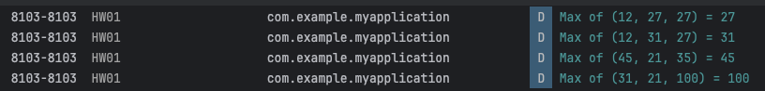

Your Code)
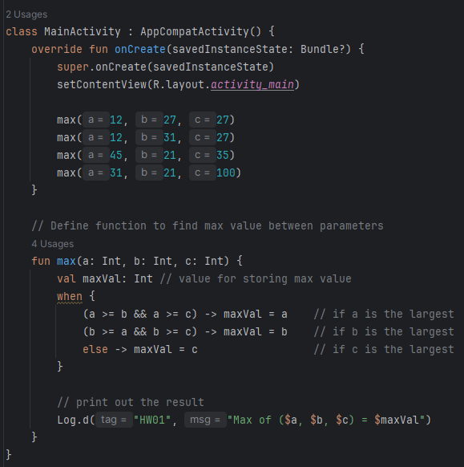
Your Output)
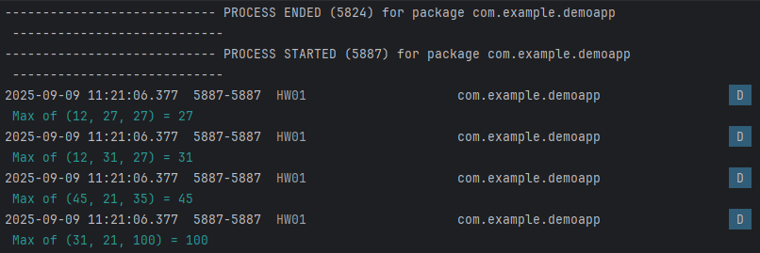

2. Write a program that 1) takes a positive integer number N (less than 100), 2) creates an integer array with the size of N, 3) fills in this array using a set of random numbers ranging from 1~100, 4) prints out the numbers in this array. Note that this array MUST NOT have the duplicate numbers.

Code base)

val capacity = 10 // modify this for test
// implement here
Log.d("HW01", "result: $myUniqueArray, capacity: $capacity")

Output example)

Your Code)
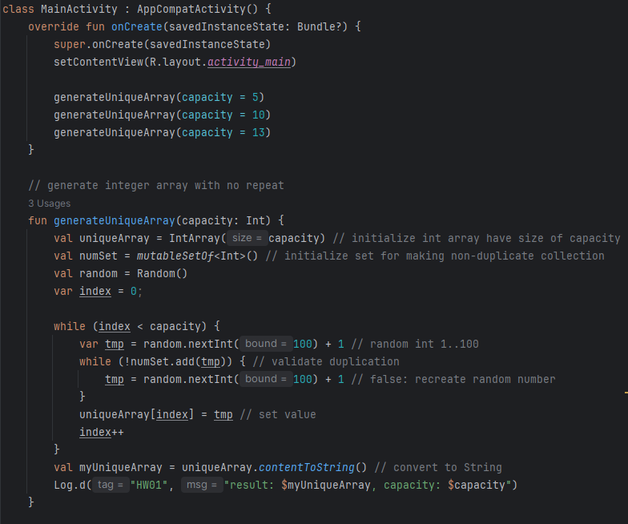
Your Output)
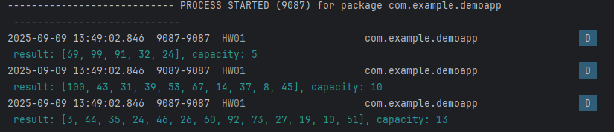

3. Count vowels and consonants, ignoring non-letters. Count only letters in a case-insensitive way.

Code base)

val line = "Android and Kotlin are fun!" // modify for test

// implement here

Log.d("HW01", "\"$line\" -> vowels: $vowelsCount, consonants: $consonantsCount")

Output example)

Your Code)
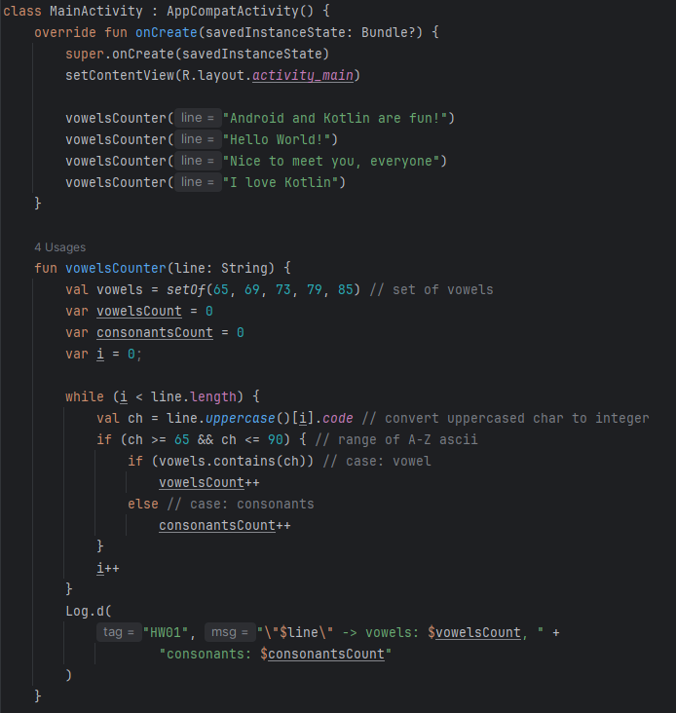
Your Output)
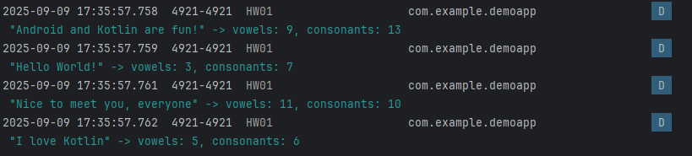

4. Write a program that takes a string, rotates it one character at a time, and prints it all. Use “While” Loop.

Code base)
var str = "I Love Kotlin" // modify this for test
Log.d("HW01",str)
// implement here

Output)
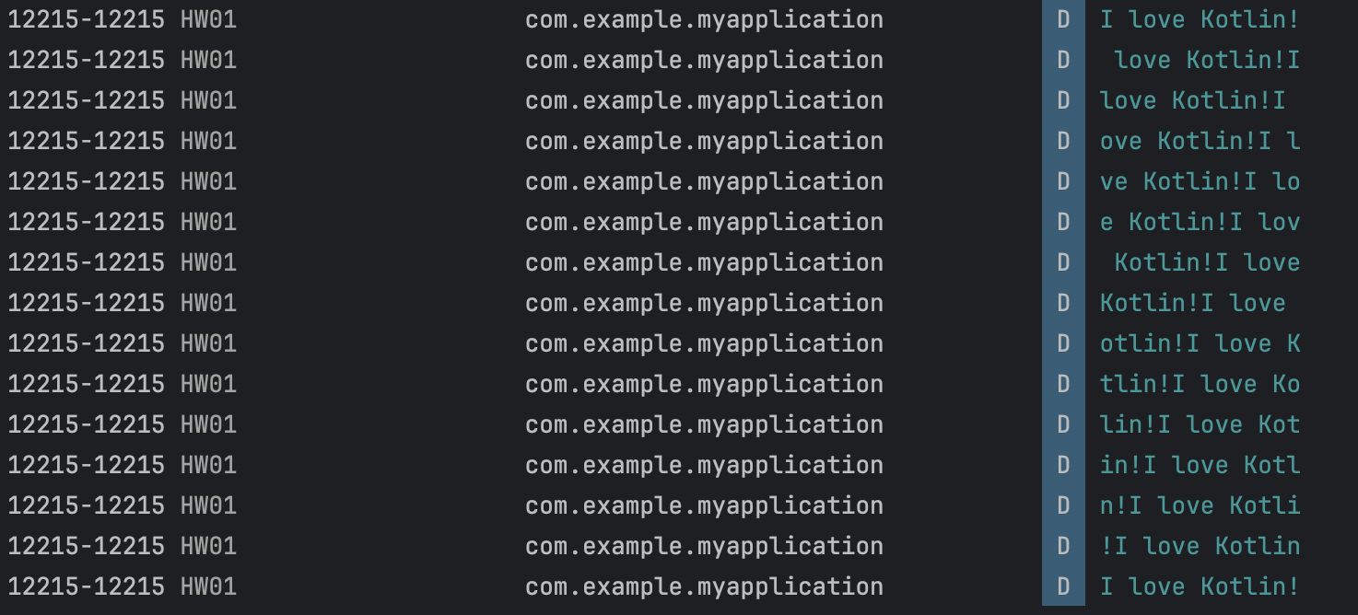

Your Code)
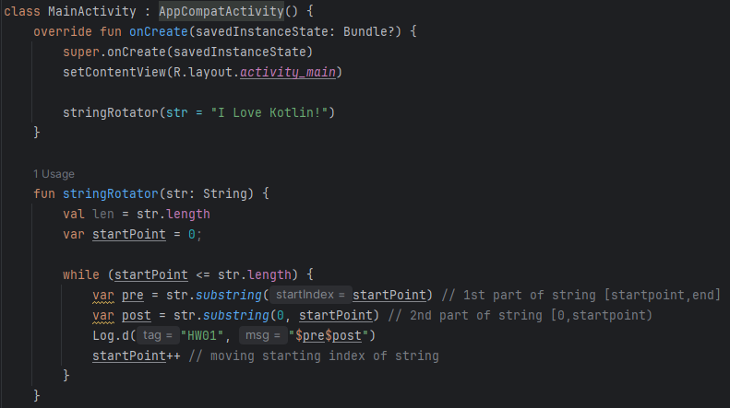

Your Output)
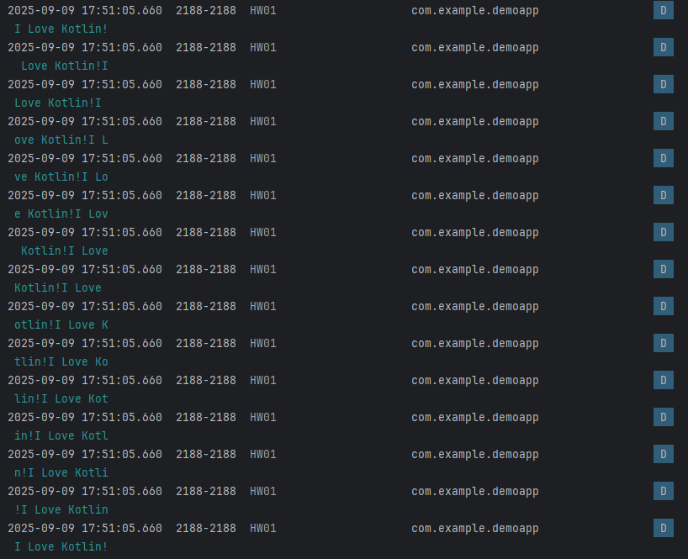

5. Write a code to check if a given string is palindrome or not. Use String-related functions.

Code base)

val str = "jinwoo" // modify this for test

// implement here

Output example)

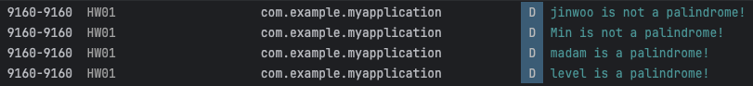

Your Code)
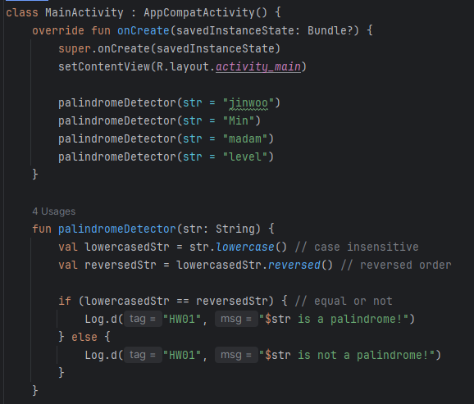

Your Output)
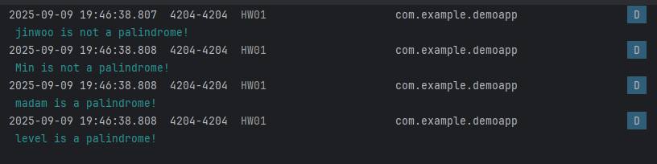

6. Compute n! with a loop; optionally also show recursion-based method. Assume 0 ≤ n ≤ 20.

Code base)

val n = 6 // modify for test

// implement here

Log.d("HW01", "factorial($n) by loop = $factLoop")

// optional recursion log

Output example)

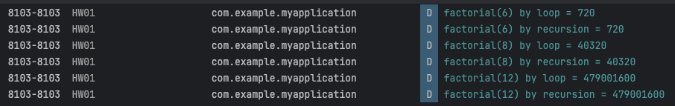

Your Code)
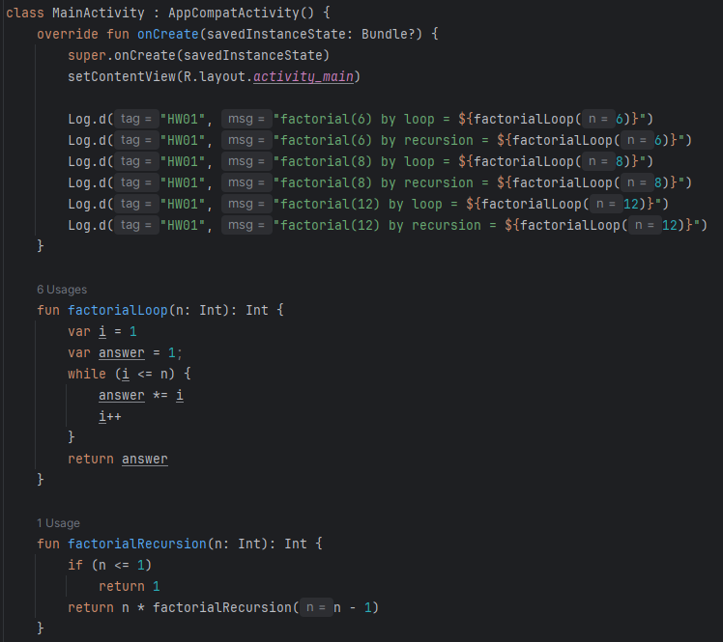
Your Output)
